**DAILY ONLINE ACTIVITIES SUMMARY**

|  |  |  |  |  |  |  |  |  |
| --- | --- | --- | --- | --- | --- | --- | --- | --- |
| **Date:** | **02-7-2020** | | | | | **Name:** | **Poojashree T** | |
| **Sem & Sec** | **8th sem B sec** | | | | | **USN:** | **4al16cs064** | |
| **Online Test Summary** | | | | | | | | |
| **Subject** | | **No Test** | | | | | | |
| **Max. Marks** | |  | | **Score** | | |  | |
| **Certification Course Summary** | | | | | | | | |
| **Course** | **Introduction to R language tutorial** | | | | | | | |
| **Certificate Provider** | | | **Great learning academy** | | **Duration** | | | **3.0hr** |
| **Coding Challenges** | | | | | | | | |
| **Problem Statement:** **1**. **to read the number and compute the series.**  **2. to count the number in th series.**  **3. to check whether number is palindrome or not.**  **4. to find the number between 0 and 50 which are not divisible by 2 and 3.**  **5.micro and array update**  Top of Form | | | | | | | | |
| **Status:completed** | | | | | | | | |
| **Uploaded the report in Github** | | | | | **yes** | | | |
| **If yes Repository name** | | | | | **Poojatgowda** | | | |
| **Uploaded the report in slack** | | | | | **yes** | | | |

**Online test**

No Test

**Certification course**

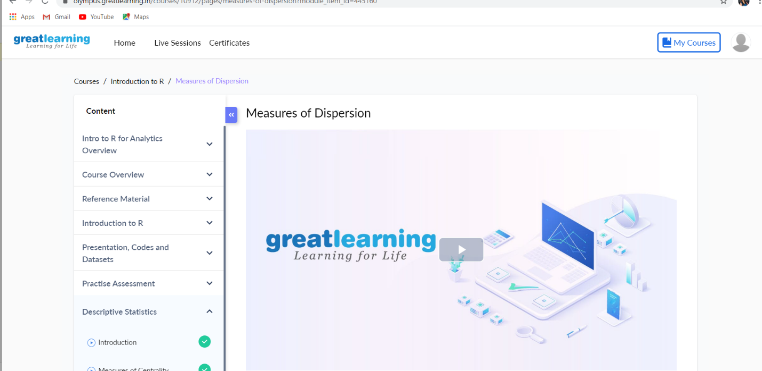

## **Example: Program to check Vowel or Consonant**

import java.util.Scanner;

class JavaExample

{

public static void main(String[ ] arg)

{

boolean isVowel=false;;

Scanner scanner=new Scanner(System.in);

System.out.println("Enter a character : ");

char ch=scanner.next().charAt(0);

scanner.close();

switch(ch)

{

case 'a' :

case 'e' :

case 'i' :

case 'o' :

case 'u' :

case 'A' :

case 'E' :

case 'I' :

case 'O' :

case 'U' : isVowel = true;

}

if(isVowel == true) {

System.out.println(ch+" is a Vowel");

}

else {

if((ch>='a'&&ch<='z')||(ch>='A'&&ch<='Z'))

System.out.println(ch+" is a Consonant");

else

System.out.println("Input is not an alphabet");

}

}

}

Output 1:

Enter a character :

A

A is a Vowel

Output 2:

Enter a character :

P

P is a Consonant

Output 3:

Enter a character :

9

Input is not an alphabet

import java.util.Scanner;

class JavaExample

{

public static void main(String[ ] arg)

{

boolean isVowel=false;;

Scanner scanner=new Scanner(System.in);

System.out.println("Enter a character : ");

char ch=scanner.next().charAt(0);

scanner.close();

switch(ch)

{

case 'a' :

case 'e' :

case 'i' :

case 'o' :

case 'u' :

case 'A' :

case 'E' :

case 'I' :

case 'O' :

case 'U' : isVowel = true;

}

if(isVowel == true) {

System.out.println(ch+" is a Vowel");

}

else {

if((ch>='a'&&ch<='z')||(ch>='A'&&ch<='Z'))

System.out.println(ch+" is a Consonant");

else

System.out.println("Input is not an alphabet");

}

}

}

Output 1:

Enter a character :

A

A is a Vowel

Output 2:

Enter a character :

P

P is a Consonant

Output 3:

Enter a character :

9

Input is not an alphabet